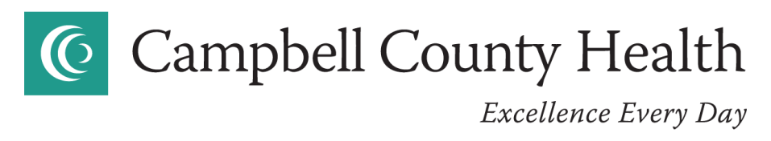
Board Meeting Agenda
April 28, 2022
Campbell County Hospital – 5th Floor Classroom
5:00 PM
- PLEDGE OF ALLEGIANCE
- CONVENE REGULAR BOARD MEETING
- OPENING
    - Call to Order
    - Mission Statement
    - Vision Statement
- ROLL CALL
- APPROVAL OF AGENDA
- CONSENT AGENDA
    - Requiring Board Action from the March 22, 2022 Finance Committee Meeting
    - Medical Staff Appointments
- RECOGNITION ITEMS
    - Employee Recognition
- PUBLIC QUESTIONS OR COMMENTS
- DISCUSSION ITEMS
    - Contract Approval Process
    - Foundation Mediation Update
    - Automatic Expiration of Medical Staff Privileges of Employed Providers if Employment Contract Ends
    - CCH Board Education Proposal from UCHealth
    - Unidine Cafeteria Remodel Concept
    - Should PRSC Financials be included in CCH Financials
- ACTION ITEMS
    - Approval of Utilization Management (UM) Committee Providers
- INFORMATIONAL ITEMS
- Chairman’s Report
- Chief of Staff Report
- Chief Medical Officer Report
- UCHealth Report
- CEO Report
  - New CEO Update
  - Home Health Recognition by CMS
  - Recognition Letters
  - Articles for Review
- Finance Report

- EXECUTIVE SESSION – CCH Board Room
(1) Real Estate Purchase
(2) Security of Public or Organizational Personnel
(3) Classified Confidential Quality Measurements
(4) Classified Confidential Attorney Client Privileged Matters
(5) Classified Confidential Medical Information
(6) Retention of a Professional Person
(7) Staff Disciplinary (Organizational or Professional)
(8) Litigation
- ADJOURNMENT

